**Aycan’s notes**

**Linear Regression**

* I think it will be nice to show [curve fitter app](https://www.mathworks.com/help/curvefit/curvefitter-app.html)/[regression learner app.](https://www.mathworks.com/help/stats/regression-learner-app.html) That’s one of the main advantages of using MATLAB. Some ways you can incorporate interactive workflows into the scripts:
* Adding relevant documentation links and mentioning in the descriptions that it is possible to do the tasks interactively. You can also describe the steps in the text.
* Adding screenshots to describe interactive approach
* Linking MathWorks videos or recording your screen while doing things interactively and adding video link to Live Script

I am fine with either approach to mention interactive workflows. Some users may not be as familiar with MATLAB or programming, interactive workflows ease programming for them. If you follow Machine Learning Onramp etc., these self-paced online trainings usually cover easy ways/best practices. They’ll give you good ideas. You can also review getting started videos on product pages, they usually highlight interactive workflows. For example, [getting started with curve fitting app video](https://www.mathworks.com/videos/how-to-perform-curve-fitting-using-the-curve-fitting-app-in-matlab-1613394490506.html)

* Code Analyzer underlined Line 60 – make sure to preallocate, good programming practice. If you can address MATLAB Code Analyzer warnings when possible, that would be great. Code Analyzer warnings are underlines and orange markings on the right side of your script, if you go over them, Code Analyzer has some suggestions on how to address some issues like preallocation. More information on Code Analyzer: <https://www.mathworks.com/help/matlab/matlab_prog/check-code-for-errors-and-warnings.html>
* If you’ll talk about parallel computing or handling large data, you can add relevant doc examples/articles such as this one: <https://www.mathworks.com/company/newsletters/articles/regression-strategies-for-large-datasets.html>
* MATLAB in-tool apps: <https://www.mathworks.com/discovery/matlab-apps.html> (you can check in-tool apps, these come with toolboxes and let user do tasks interactively. If you see an app to do the task you want to do programmatically, I recommend using app to balance coding with interactive work)

**Polymer melt**

* Do you use all the outputs of statistics function? Would [summary](https://www.mathworks.com/help/matlab/ref/table.summary.html) do the job?
* You can use [Live Tasks](https://www.mathworks.com/help/matlab/matlab_prog/add-live-editor-tasks-to-a-live-script.html) to clean outliers etc.
* Divide data, above line 86 this part seems like it is related to Python, not MATLAB: The train_test_split is a function in sklearn for the specific purpose of splitting data into train and test sets.
* Show interactive approach using regression learner app

**Jon’s notes**

**Some things to think about:**

* **Imbalanced.mlx**
  + Providing a quick description of what is about to take place
  + Discuss plots that are created
  + Quickly Explain onfusionmatStats to obtain Fscore, line173
  + Typo…? “Create ModelsMake” line 162
  + Quick intuition about things being presented
  + Maybe a quick summary at the end
* **Support_Vector_Validated.mlx**
  + Notation in the constrained optimization problem, eps
  + Difference, not the sum, in the constraint
  + Maybe a few images to show the difference between SVM and SVR
  + The description of SVR is a little misleading. Keep in mind SVR is inherently a minimization problem. The idea is to adjust the slack variable to incorporate points outside the margin, BUT not too many, since we still want to minimize error.

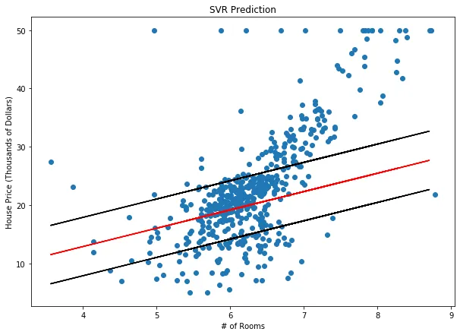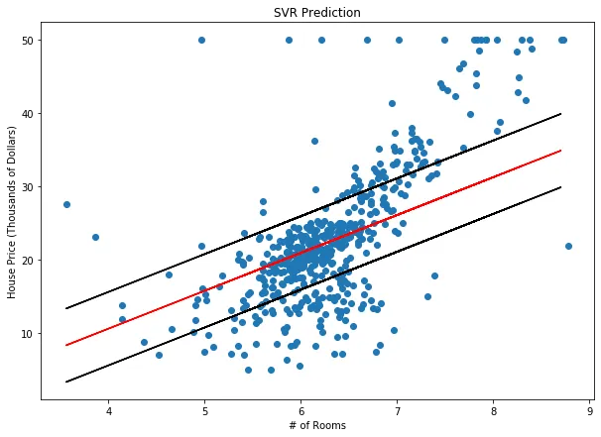

Credit: Towards Data Science

* + Where is “gamma”? be careful when copying and pasting

[Efficient Learning Machines](https://link.springer.com/chapter/10.1007/978-1-4302-5990-9_4)

**Good job overall!** 😊